Incel Protection Force Service Awards Protocol
Note: all awards are listed by order of precedence in descending order
Decoration Name | Requirements for award | Ribbon/uniform device | Conferring authority | Purchase option
IPF Mission Specialist First Class | Awarded to any member of the IPF who verifiably attends four or more real-world meet-ups |  | Awarded by the CO | https://www.supplyroomjrotc.com/army-jrotc/product/11002/oval-rc-309-gold-4th-award/
IPF Mission Specialist Second Class | Awarded to any member of the IPF who verifiably attends a third real-world meet-up | 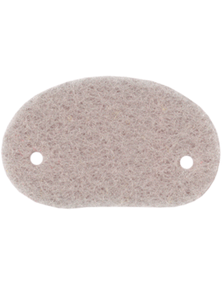 | Awarded by the CO | https://www.supplyroomjrotc.com/army-jrotc/product/11003/oval-rc-308-silver-3rd-award/
IPF Mission Specialist Third Class | Awarded to any member of the IPF who verifiably attends a second real-world meet-up |  | Awarded by the CO | https://www.supplyroomjrotc.com/army-jrotc/product/5765/oval-rc-307-red-2nd-award/
IPF Mission Specialist Fourth Class | Awarded to any member of the IPF who verifiably attends a real-world meet-up |  | Awarded by the CO | https://www.supplyroomjrotc.com/army-jrotc/product/17407/academic-achievement-wreath
IPF Medal of Valor | Recipient must demonstrate great personal courage in the face of adversity | 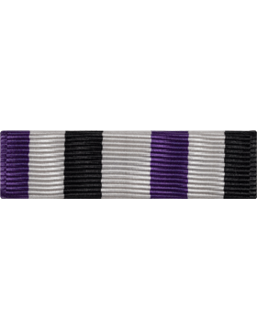 | Awarded by unanimous consent of the leadership staff | https://www.supplyroomjrotc.com/army-jrotc/product/17725/rotc-ribbon-rc-r210-optional-r-1-10/
IPF Distinguished Service Ribbon | Recipient must contribute substantially to the strategic success of the IPF/ILM | 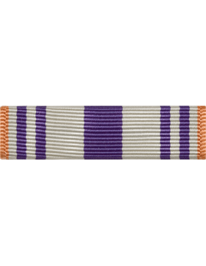 | Awarded by unanimous consent of the leadership staff | https://www.supplyroomjrotc.com/army-jrotc/product/25104/rotc-ribbon-rc-r150-optional-n-4-5/
Master Sergeant Kevin Debruyne Memorial Ribbon | Awarded to any comrade who contributes substantially to the vibrancy and vitality of the Incel movement | 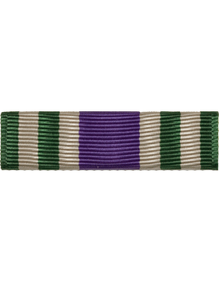 | Awarded by a majority vote of all IPF/ILM comrades on the basis of stipulated criteria | https://www.supplyroomjrotc.com/army-jrotc/product/19611/rotc-ribbon-rc-r109-optional-n-1-9/
IPF Exemplary Service Ribbon | Recipient must meaningfully contribute to the advancement of the cause | 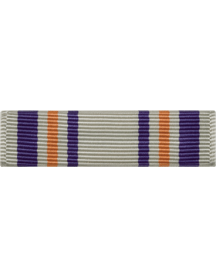 | Awarded per the discretion of the Commanding Officer (CO) | https://www.supplyroomjrotc.com/army-jrotc/product/19616/rotc-ribbon-rc-r149-optional-n-4-4/
IPF Personal Achievement Ribbon First Class | Recipient is recognized for outstanding personal achievement | 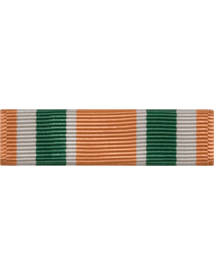 | Awarded per the discretion of the (CO) or Chief of Staff (CoS) | https://www.supplyroomjrotc.com/army-jrotc/product/15620/rotc-ribbon-rc-r144-optional-use-n-3-14/
IPF Personal Achievement Ribbon Second Class | Recipient is recognized for superior personal achievement | 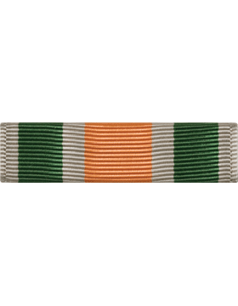 | Awarded per the discretion of the CO, CoS or Operations Manager (OM) | https://www.supplyroomjrotc.com/army-jrotc/product/15621/rotc-ribbon-rc-r145-optional-use-n-3-15/
IPF Personal Achievement Ribbon Third Class | Recipient is recognized for personal achievement | 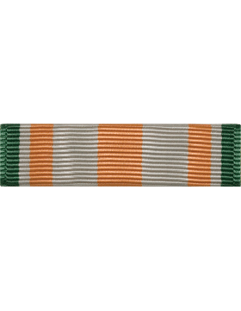 | Awarded per the discretion of the CO, CoS or OM | https://www.supplyroomjrotc.com/army-jrotc/product/15658/rotc-ribbon-rc-r143-optional-use-n-3-13/
IPF Good Conduct Ribbon | Recipient is recognized for good conduct as a soldier of the IPF | 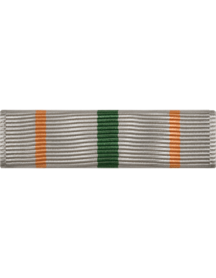 | Awarded per the discretion of the CO, CoS or OM | https://www.supplyroomjrotc.com/army-jrotc/product/11766/rotc-ribbon-rc-r140-good-conduct-n-3-10/
IPF Staff Service Ribbon | Recipient has served as a member of the IPF staff for at least one month | 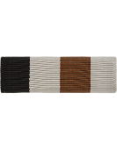 | Awarded per the discretion of the CO, CoS or OM | https://www.supplyroomjrotc.com/army-jrotc/product/73304/rotc-ribbon-rc-r228-optional-use-r-2-8/
IPF Long Service Ribbon First Class | Recipient has served in the IPF as a member in good standing for more than six months’ time | 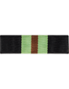 | Awarded per the discretion of the CO, CoS or OM | https://www.supplyroomjrotc.com/army-jrotc/product/17727/rotc-ribbon-rc-r227-optional-r-2-7/
IPF Long Service Ribbon Second Class | Recipient has served in the IPF as a member in good standing for more than three months’ time | 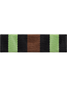 | Awarded per the discretion of the CO, CoS or OM | https://www.supplyroomjrotc.com/army-jrotc/product/17730/rotc-ribbon-rc-r230-optional-415-r-2-10/
IPF Commanders Recognition Ribbon First Class | Awarded to any member of the IPF whom the CO feels is worthy of special recognition for exceptional service | 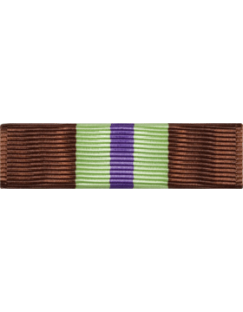 | Awarded per the discretion of the CO | https://www.supplyroomjrotc.com/army-jrotc/product/25305/rotc-ribbon-rc-r244-optional-r-4-4/
IPF Commanders Recognition Ribbon Second Class | Awarded to any member of the IPF whom the CO feels is worthy of special recognition for distinguished service | 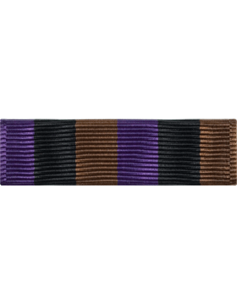 | Awarded per the discretion of the CO | https://www.supplyroomjrotc.com/army-jrotc/product/25304/rotc-ribbon-rc-r243-optional-r-4-3/
IPF Commanders Recognition Ribbon Third Class | Awarded to any member of the IPF whom the CO feels is worthy of special recognition for good service | 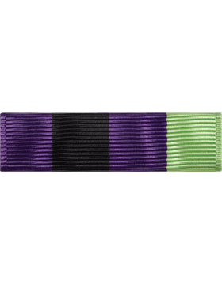 | Awarded per the discretion of the CO | https://www.supplyroomjrotc.com/army-jrotc/product/25306/rotc-ribbon-rc-r245-optional-r-4-5/
Recruitment Ribbon First Class | Awarded to any member of the IPF, ILM or IBM who successfully recruits six or more supporters to the cause | 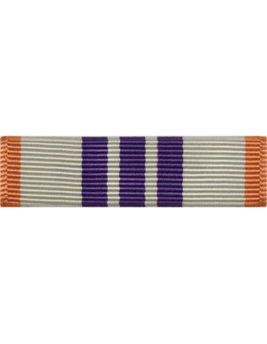 | Awarded per the discretion of the Recruitment Supervisor | https://www.supplyroomjrotc.com/army-jrotc/product/19617/rotc-ribbon-rc-r147-recruiting-n-4-2/
Recruitment Ribbon Second Class | Awarded to any member of the IPF, ILM or IBM who successfully recruits three supporters to the cause | 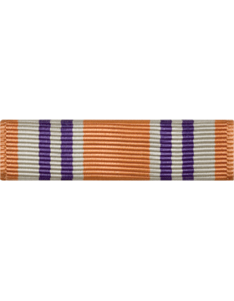 | Awarded per the discretion of the Recruitment Supervisor | https://www.supplyroomjrotc.com/army-jrotc/product/19615/rotc-ribbon-rc-r148-optional-n-4-3/
Forum Recognition Ribbon First Class | Awarded to any member of the IPF, ILM or IBM who has maintained top active user status for more than 3 consecutive months | 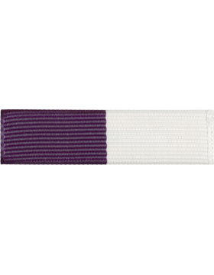 | Awarded per the discretion of the CO, CoS or OM | https://www.supplyroomjrotc.com/army-jrotc/product/15145/u-r203-purple-and-white-720/
Forum Recognition Ribbon Second Class | Awarded to any member of the IPF, ILM or IBM who has maintained top active user status for more than 4 consecutive weeks | 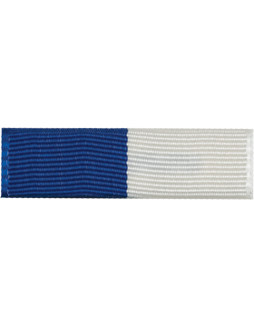 | Awarded per the discretion of the CO, CoS or OM | https://www.supplyroomjrotc.com/army-jrotc/product/15146/u-r204-royal-and-white-773/
Forum Recognition Ribbon Third Class | Awarded to any member of the IPF, ILM or IBM who has maintained top active user status for more than 7 consecutive days | 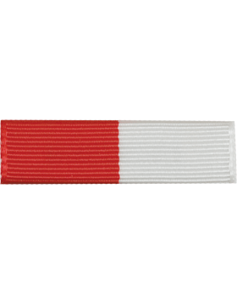 | Awarded per the discretion of the CO, CoS or OM | https://www.supplyroomjrotc.com/army-jrotc/product/15144/u-r202-red-and-white-714/
Islamic Faith Badge First Class | Satisfied prerequisites for previous badge, righteous actions taken in furtherance of the propagation of Salafi and/or Wahabi Islam |  | Conferred by unanimous consent of leadership staff | https://www.amazon.com/Islam-Allah-Ayatul-Kursi-Shahadah/dp/B0C9H81WJP?source=ps-sl-shoppingads-lpcontext&ref_=fplfs&psc=1&smid=A6BVY9MGJ2UGQ&gQT=1
Islamic Faith Badge Second Class | Satisfied prerequisites for previous badge, demonstrable expert knowledge of Islamic teachings as assessed by resident Islamic scholar |  | Designated Resident Islamic Scholar who shall always be the most learned Muslim in the service of the IPF | https://www.amazon.com/Islam-Ayatul-Kursi-Quran-Lapel/dp/B0B42JN6K3?source=ps-sl-shoppingads-lpcontext&ref_=fplfs&psc=1&smid=A6BVY9MGJ2UGQ&gQT=1
Islamic Faith Badge Third Class | Profession of faith made publicly in the forums, consistent evidence of knowledge of and obedience to Islam, final approval made by resident Islamic scholar |  | Designated Resident Islamic Scholar who shall always be the most learned Muslim in the service of the IPF | https://www.amazon.com/Novel-Merk-Crescent-Religious-Clutch/dp/B0CK45Z1HG?source=ps-sl-shoppingads-lpcontext&ref_=fplfs&psc=1&smid=AL4MJBJ77Y9FY&gQT=1
Forum Engagement Star First Class | Awarded to any member of the IPF, ILM or IBM who has created 3000 posts |  | Automatically conferred on the basis of post count | https://www.amazon.com/StockPins-J34-Colored-Star-Pin/dp/B0088ARVXI
Forum Engagement Star Second Class | Awarded to any member of the IPF, ILM or IBM who has created 1000 posts | 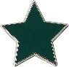 | Automatically conferred on the basis of post count | https://www.amazon.com/StockPins-J34-Colored-Star-Pin/dp/B0088ARVXI
Forum Engagement Star Third Class | Awarded to any member of the IPF, ILM or IBM who has created 500 posts |  | Automatically conferred on the basis of post count | https://www.amazon.com/StockPins-J34-Colored-Star-Pin/dp/B0088ARVXI
Forum Engagement Star Fourth Class | Awarded to any member of the IPF, ILM or IBM who has created 250 posts |  | Automatically conferred on the basis of post count | https://www.amazon.com/StockPins-J34-Colored-Star-Pin/dp/B0088ARVXI
Forum Engagement Star Fifth Class | Awarded to any member of the IPF, ILM or IBM who has created 100 posts |  | Automatically conferred on the basis of post count | https://www.amazon.com/StockPins-J34-Colored-Star-Pin/dp/B0088ARVXI

