Incel Protection Force Service Awards Protocol
Decoration Name | Requirements for award | Ribbon/uniform device | Conferring authority | Purchase option
IPF Medal of Valor | Recipient must demonstrate great personal courage in the face of adversity | 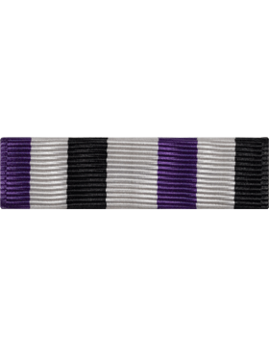 | Awarded by unanimous consent of the leadership staff | https://www.supplyroomjrotc.com/army-jrotc/product/17725/rotc-ribbon-rc-r210-optional-r-1-10/
IPF Distinguished Service Ribbon | Recipient must contribute substantially to the strategic success of the IPF/ILM | 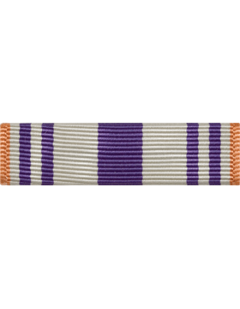 | Awarded by unanimous consent of the leadership staff | https://www.supplyroomjrotc.com/army-jrotc/product/25104/rotc-ribbon-rc-r150-optional-n-4-5/
IPF Exemplary Service Ribbon | Recipient must meaningfully contribute to the advancement of the cause | 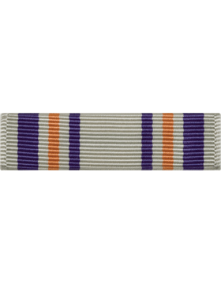 | Awarded per the discretion of the Commanding Officer (CO) | https://www.supplyroomjrotc.com/army-jrotc/product/19616/rotc-ribbon-rc-r149-optional-n-4-4/
IPF Personal Achievement Ribbon First Class | Recipient is recognized for outstanding personal achievement | 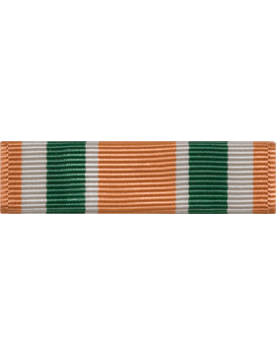 | Awarded per the discretion of the (CO) or Chief of Staff (CoS) | https://www.supplyroomjrotc.com/army-jrotc/product/15620/rotc-ribbon-rc-r144-optional-use-n-3-14/
IPF Personal Achievement Ribbon Second Class | Recipient is recognized for superior personal achievement | 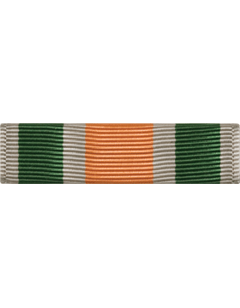 | Awarded per the discretion of the CO, CoS or Operations Manager (OM) | https://www.supplyroomjrotc.com/army-jrotc/product/15621/rotc-ribbon-rc-r145-optional-use-n-3-15/
IPF Personal Achievement Ribbon Third Class | Recipient is recognized for personal achievement | 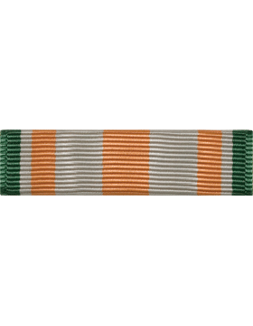 | Awarded per the discretion of the CO, CoS, OM or a department head (DH) | https://www.supplyroomjrotc.com/army-jrotc/product/15658/rotc-ribbon-rc-r143-optional-use-n-3-13/
IPF Good Conduct Ribbon | Recipient is recognized for good conduct as a soldier of the IPF | 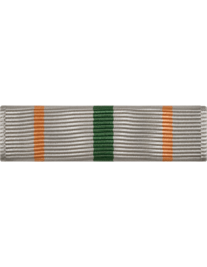 | Awarded per the discretion of the CO, CoS, OM or a department head (DH) | https://www.supplyroomjrotc.com/army-jrotc/product/11766/rotc-ribbon-rc-r140-good-conduct-n-3-10/
IPF Staff Service Ribbon | Recipient has served as a member of the IPF staff for at least one month | 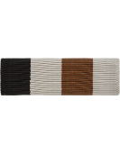 | Awarded per the discretion of the CO, CoS or OM | https://www.supplyroomjrotc.com/army-jrotc/product/73304/rotc-ribbon-rc-r228-optional-use-r-2-8/
IPF Long Service Ribbon First Class | Recipient has served in the IPF as a member in good standing for more than three months’ time | 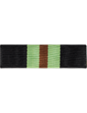 | Awarded per the discretion of the CO, CoS or OM | https://www.supplyroomjrotc.com/army-jrotc/product/17727/rotc-ribbon-rc-r227-optional-r-2-7/
IPF Long Service Ribbon Second Class | Recipient has served in the IPF as a member in good standing for more than one month’s time | 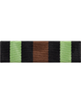 | Awarded per the discretion of the CO, CoS or OM | https://www.supplyroomjrotc.com/army-jrotc/product/17730/rotc-ribbon-rc-r230-optional-415-r-2-10/
IPF Commanders Recognition Ribbon | Awarded to any member of the IPF whom the CO feels is worthy of special recognition | 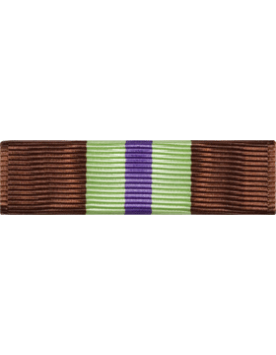 | Awarded per the discretion of the CO | https://www.supplyroomjrotc.com/army-jrotc/product/25305/rotc-ribbon-rc-r244-optional-r-4-4/
Chief of Staff’s Recognition Ribbon | Awarded to any member of the IPF whom the CoS feels is worthy of special recognition | 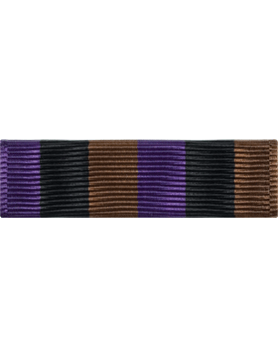 | Awarded per the discretion of the CoS | https://www.supplyroomjrotc.com/army-jrotc/product/25304/rotc-ribbon-rc-r243-optional-r-4-3/
Department Head’s Recognition Ribbon | Awarded to any member of the IPF whom a DH feels is worthy of special recognition | 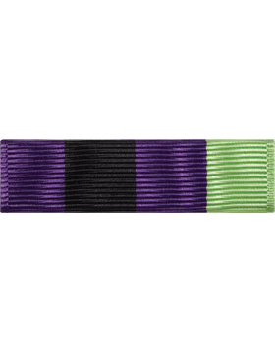 | Awarded per the discretion of any DH | https://www.supplyroomjrotc.com/army-jrotc/product/25306/rotc-ribbon-rc-r245-optional-r-4-5/
Recruitment Ribbon First Class | Awarded to any member of the IPF, ILM or IBM who successfully recruits more than three supporters to the cause | 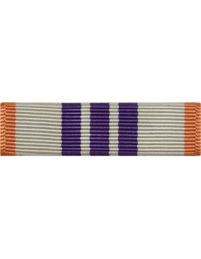 | Awarded per the discretion of the Recruitment Supervisor | https://www.supplyroomjrotc.com/army-jrotc/product/19617/rotc-ribbon-rc-r147-recruiting-n-4-2/
Recruitment Ribbon Second Class | Awarded to any member of the IPF, ILM or IBM who successfully recruits more than three supporters to the cause | 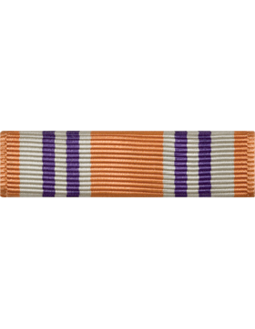 | Awarded per the discretion of the Recruitment Supervisor | https://www.supplyroomjrotc.com/army-jrotc/product/19615/rotc-ribbon-rc-r148-optional-n-4-3/
Forum Recognition Ribbon First Class | Awarded to any member of the IPF, ILM or IBM who has maintained top active user status (ranked #1) for more than 7 consecutive days | 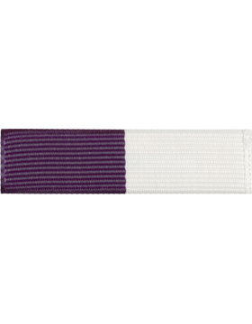 | Awarded per the discretion of the CO, CoS or OM | https://www.supplyroomjrotc.com/army-jrotc/product/15145/u-r203-purple-and-white-720/
Forum Recognition Ribbon Second Class | Awarded to any member of the IPF, ILM or IBM who has maintained top active user status (ranked #1) for more than 3 consecutive days | 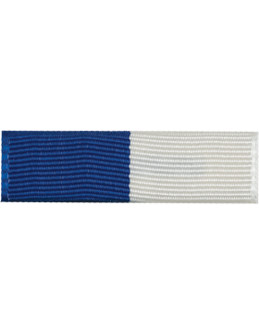 | Awarded per the discretion of the CO, CoS or OM | https://www.supplyroomjrotc.com/army-jrotc/product/15146/u-r204-royal-and-white-773/
Forum Recognition Ribbon Third Class | Awarded to any member of the IPF, ILM or IBM who has maintained top active user status (ranked #1) for more 24 hours | 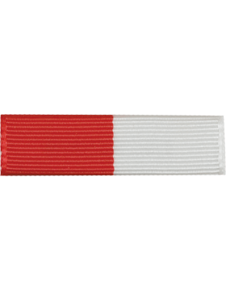 | Awarded per the discretion of the CO, CoS or OM | https://www.supplyroomjrotc.com/army-jrotc/product/15144/u-r202-red-and-white-714/

